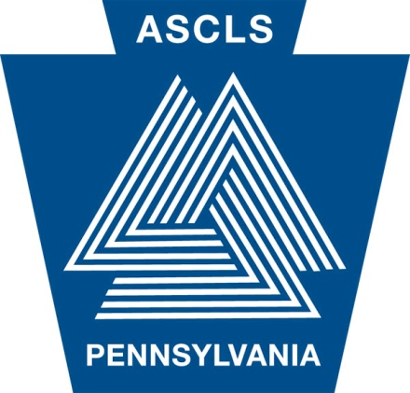
Student Review 2015
AMERICAN SOCIETY FOR CLINICAL LABORATORY SCIENCE – PA
Your Professional Organization for over 75 years
Chartered in 1935
MLS/MLT Student Review Session
June 6, 2015
Registration: 8:00 - 8:30am
Review: 8:30am - 4:30pm

Location: University of the Sciences
Pharmacology/Toxicology Center (PTC), Room 140
Agenda: Review of Chemistry/Urinalysis, Hematology/Coagulation, Microbiology, Immunohematology/Immunology and Test Taking Tips
Registration fee includes lunch and handouts!
ASCLS-PA is a PACE provider
Questions:
Contact: Ryan Stetz
c/o Jean Buchenhorst, PAH MLS Program Director
800 Spruce Street
Cathcart Building, Room CA-S19
Philadelphia, PA 19107

Phone: (570) 590-3175
Email: Ryan.Stetz@uphs.upenn.edu
Registration Deadline: 05/26/15

Name: | Phone:
Institution: | ASCLS Membership #:
Address:  City/State/Zip: | Email:

Registration Fees:

Check one: | Status: | Cost: | Total:
 | Student ASCLS member | $30.00
 | Student ASCLS non-member | $40.00
 | Non-student ASCLS member | $50.00
 | Non-student ASCLS non-member | $60.00
 | Late Fee (after 05/26/15) | $10.00
Grand
Total:

Mail Registration form and check (made payable to ASCLS-PA) to:
Ryan Stetz
c/o Jean Buchenhorst, PAH MLS Program Director
800 Spruce Street
Cathcart Building, Room CA-S19
Philadelphia, PA 19107

USciences’ Campus Map including Driving and Public Transportation directions:
http://www.usciences.edu/virtualtour/USP.pdf

USciences’ Campus address is:
600 South 43rd Street
Philadelphia, PA 19104

All profits go to the ASCLS-PA student forum.

