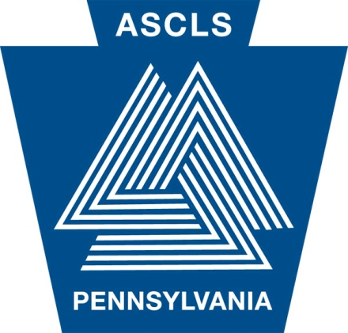

Your Professional Organization for over 75 Years
Chartered in 1935

AMERICAN SOCIETY FOR CLINICAL LABORATORY SCIENCE – PA

Host of the 2016 MLS/MLT Student Review Session

Date: June 4, 2016

Location: University of the Sciences (Philadelphia, PA)
Pharmacology/Toxicology Center (PTC), Room 140

Agenda: Review of Chemistry & Urinalysis, Hematology & Coagulation, Immunology, Microbiology, Immunohematology and Test Taking Tips

Registration: 8:00 – 8:30 AM
Review: 8:30 AM – 5:00 PM

Fees:
Student ASCLS member: $30
Student ASCLS non-member: $40
Non-student ASCLS member: $50
Non-student ASCLS non-member: $60
Late Fee (after 5/21/2016): $10

Registration fee includes lunch and handouts

For a registration form and more information,
please email Joshua Cannon at JXC313@jefferson.edu
or visit www.ascls-pa.org

